WEEK 8
Week Ending: 24-10-2025 |  | DAY: |  | Subject: COMPUTING
Duration: 50mins |  |  |  | Strand: Productivity Software
Class: B7 |  | Class Size: |  | Sub Strand: Introduction to Word Processing
Content Standard:  B7.2.1.1 Demonstrate how to use Microsoft Word (Editing) |  |  | Indicator:  B7.2.1.1.7 Demonstrate how to set tabs and apply formatting |  |  |  | Lesson:  1 of 1
Performance Indicator:  Learners can;  - Understand the function of the Tab button in Microsoft Word.  - Set center and right tabs using the ruler and the Tabs dialog box.  - Format text using tabs for alignment. |  |  |  |  | Core Competencies:  Communication and Collaboration, Critical Thinking and Problem solving
References: Computing Curriculum Pg.
Keywords: Tab Button, Center Tab, Right Tab, Ruler, Tabs Dialog Box
Phase/Duration | Learners Activities |  |  |  |  | Resources
PHASE 1: STARTER | Begin by asking learners if they know how to align text in a document. Discuss different alignment methods, such as using the spacebar, but emphasize the precision and efficiency of using tabs.  Demonstrate how text can be misaligned when using the spacebar versus the Tab button. Highlight how tabs create cleaner, more organized documents.
PHASE 2: NEW LEARNING | Introduce the concept of tabs in Microsoft Word, explaining the difference between left, center, and right tabs.  Focus on the center and right tabs for this lesson.  Explain how using tabs can improve document layout, especially for creating tables of content, aligning columns of text, or formatting lists.  Demonstrate how to set a center tab using the ruler in Microsoft Word. Show how text aligns around the center tab when typed.  Learners to demonstrate how to set a right tab using the ruler. Show how text aligns to the right margin when typed.  Explain how to open the Tabs dialog box for more precise tab settings. Show how to set, clear, and adjust tab stops from this menu.  Demonstrate how to apply different formatting options (font size, style, color) after setting tabs, showing how it affects the aligned text.  Use a sample document to show how to set center and right tabs and format the aligned text.  Highlight how to preview and adjust tab settings using the ruler and dialog box.  Provide learners with a practice document where they will need to set center and right tabs to align text, such as a list of items or a simple table.  - Set a center tab at a specific position on the ruler.  - Set a right tab at another specific position.  - Apply formatting to the aligned text.  Provide step-by-step instructions with visuals for learners who need extra help. Offer one-on-one support to ensure comprehension.  Assessment  - How do you set a center tab using the ruler in Microsoft Word?  - Describe the steps to set a right tab using the Tabs dialog box.  - What is the advantage of using tabs over the spacebar for alignment? |  |  |  |  | Computers with Microsoft Word installed  Sample document for practice
PHASE 3: REFLECTION | - How can you clear a tab stop and reset it?  - Explain how to apply formatting to text after setting a tab stop.  Use peer discussion and effective questioning to find out from learners what they have learnt during the lesson.  Take feedback from learners and summarize the lesson.

Week Ending: 24-10-2025 |  | DAY: |  | Subject: COMPUTING
Duration: 50mins |  |  |  | Strand: Communication Networks
Class: B7 |  | Class Size: |  | Sub Strand: Computer Networks
Content Standard:  B7.3.1.1 Identify the concept of computer networking for global communications |  |  | Indicator:  B7.3.1.1.1 Explain computer networking and explore key hardware for setting up network systems |  |  |  | Lesson:  1 of 1
Performance Indicator:  Learners can;  - Define what a computer network is.  - Identify and describe the key hardware components used in setting up a computer network (e.g., server, client, hub, switch, cable). |  |  |  |  | Core Competencies:  Communication and Collaboration, Critical Thinking and Problem solving
References: Computing Curriculum Pg.
Keywords: Network, Server, Client, Hub, Switch
Phase/Duration | Learners Activities |  |  |  |  | Resources
PHASE 1: STARTER | Begin with a question: "What do you think happens when you send a message from your computer to your friend's computer?"  Use learners' responses to introduce the concept of a computer network.  Show pictures or animation that visually explains how computers connect and communicate over a network.
PHASE 2: NEW LEARNING | Define what a computer network is: a group of interconnected computers that share resources and communicate with each other.  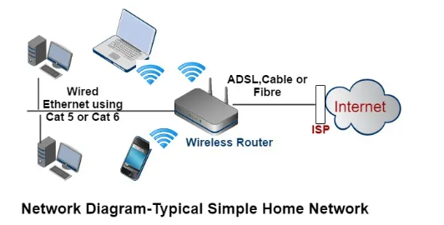  Explain why computer networks are essential in today’s world for sharing information, resources, and connecting people globally.  Guide learners to list key hardware for setting up network systems. examples ‘server, client, hub, switch, mordem, router and cables’  - Server: a server as the central computer that provides services, resources, or data to other computers (clients) on the network.  - Client: a client as any computer that accesses services and resources provided by a server.  - Hub: a hub is a basic device that connects multiple computers in a network, allowing them to communicate with each other.  - Switch: a switch is a more advanced device than a hub, which connects computers in a network and directs data to its intended destination efficiently.  - Cable: cables (like Ethernet cables) physically connect the different hardware components in a wired network.  - Modem: a device that connects your home or office network to the internet. it converts digital data from your computer into analog data to be sent over telephone lines, cable systems and vice versa.  - Router: a router connects multiple devices within a local network (like computers, phones and printers) and manages the data traffic between these devices and the internet.  Show the actual hardware components (if available) or images, and describe how each piece of hardware is used in a network.  Illustrate the connections between the components using diagrams on the whiteboard  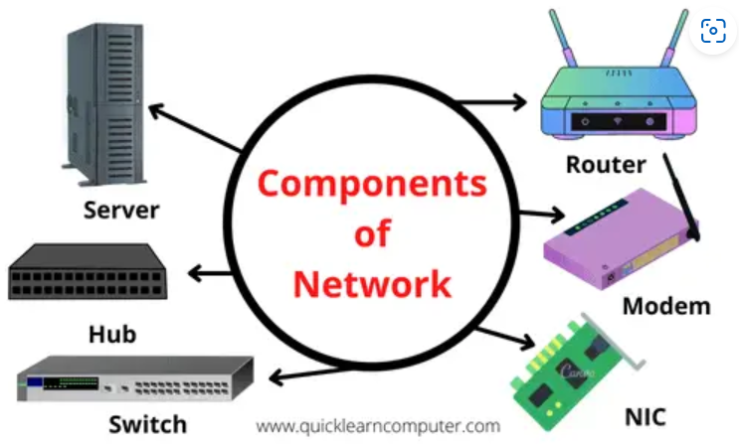  Divide learners into small groups and give them a scenario where they must identify the necessary hardware to set up a small office network.  Provide images or physical models of the hardware components.  Each group identifies the role of each component in the scenario and explains why it is needed.  Provide additional visual aids or step-by-step instructions for learners who need more help understanding the concepts.  Assessment  - What is a computer network?  - What is the role of a server in a network?  - How does a switch differ from a hub? |  |  |  |  | Computers with internet access  Networking hardware (or images of hardware) such as server, client, hub, switch, cables
PHASE 3: REFLECTION | - Why are cables important in a wired network?  - Describe how a client computer interacts with a server in a network.  Use peer discussion and effective questioning to find out from learners what they have learnt during the lesson.  Take feedback from learners and summarize the lesson.

Week Ending: 24-10-2025 |  | DAY: |  | Subject: COMPUTING
Duration: 50mins |  |  |  | Strand: Communication Networks
Class: B7 |  | Class Size: |  | Sub Strand: Computer Networks
Content Standard:  B7.3.1.1 Identify the concept of computer networking for global communications |  |  | Indicator:  B7.3.1.1.1 Draw diagrams to illustrate features of the network topologies (Bus, Star, Ring, Mesh) |  |  |  | Lesson:  1 of 1
Performance Indicator:  Learners can;  - Define network topology.  - Identify and describe different types of network topologies (e.g., Bus, Star, Ring, Mesh).  - Understand the features, advantages, and disadvantages of each topology. |  |  |  |  | Core Competencies:  Communication and Collaboration, Critical Thinking and Problem solving
References: Computing Curriculum Pg.
Keywords: Topology, Bus, Star, Ring, Mesh
Phase/Duration | Learners Activities |  |  |  |  | Resources
PHASE 1: STARTER | Start with a simple question: "How do you think computers are arranged or connected in a network?"  Use this to lead into the concept of network topologies.  Show pictures or use an animation that visualizes different types of network topologies.
PHASE 2: NEW LEARNING | Define network topology as the arrangement or layout of different elements (links, nodes, etc.) in a computer network.  Explain why understanding network topology is essential for designing and maintaining efficient networks.  Guide learners to discuss the features of the various topologies  Bus Topology: Single central cable (backbone) to which all network devices are connected. Easy to install, uses less cable. If the backbone fails, the entire network goes down.  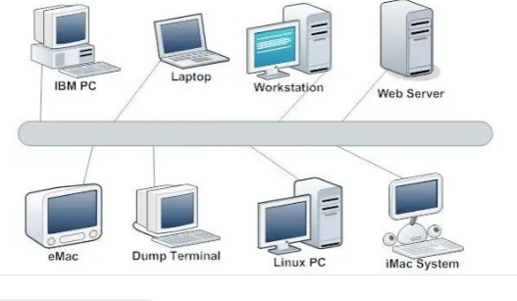  Star Topology: All devices are connected to a central hub or switch. Easy to manage, one failure doesn't bring down the entire network. If the central hub fails, the whole network is affected.  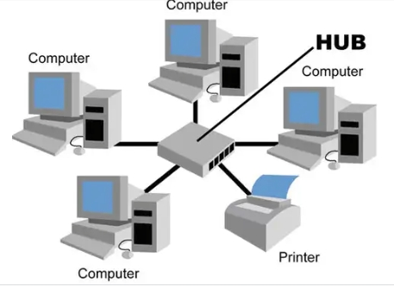  Ring Topology: Each device is connected to two other devices, forming a ring. Data travels in one direction, reducing the chances of collision. If one device fails, the entire network can be disrupted.  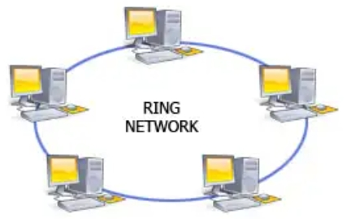  Mesh Topology: Every device is connected to every other device. Provides high redundancy and reliability. Expensive and complex to set up due to the number of cables required.  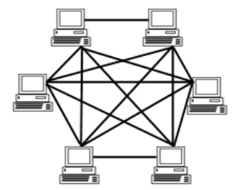  In small groups, give learners scenarios and ask them to choose the most appropriate topology for each scenario.  Provide them with printed diagrams of topologies to match with scenarios.  - A small office with limited budget and simple requirements.  - A large organization where network reliability is critical.  - A school computer lab where ease of management is important.  Provide additional diagrams and explanations for learners who need extra help understanding the concepts.  Assessment  - What is a network topology?  - Describe one advantage and one disadvantage of a Bus topology.  - Which topology would you recommend for a small office, and why? |  |  |  |  | Diagrams of different network topologies  Computers with internet access
PHASE 3: REFLECTION | - Explain why a Mesh topology is considered reliable.  2. What happens in a Ring topology if one device fails?  Use peer discussion and effective questioning to find out from learners what they have learnt during the lesson.  Take feedback from learners and summarize the lesson.

